**DAILY ONLINE ACTIVITIES SUMMARY**

|  |  |  |  |  |  |  |  |  |
| --- | --- | --- | --- | --- | --- | --- | --- | --- |
| **Date:** | **11-06-2020** | | | | | **Name:** | **Apoorva K N** | |
| **Sem & Sec** | **VI A** | | | | | **USN:** | **4AL17CS012** | |
| **Online Test Summary** | | | | | | | | |
| **Subject** | | **PAP Assignment Test-3** | | | | | | |
| **Max. Marks** | | **20** | | **Score** | | | **20** | |
| **Certification Course Summary** | | | | | | | | |
| **Course** | **Introduction to Ethical Hacking** | | | | | | | |
| **Certificate Provider** | | | **Great Learning** | | **Duration** | | | **5hr** |
| **Coding Challenges** | | | | | | | | |
| **Problem Statement:**  1. Write a python function that converts a string to all uppercase, provided it contains at least 2 uppercase characters in the first 4 characters. Else print the string as it is.  2. Python program to check whether the given number is Fibonacci or not | | | | | | | | |
| **Status: Completed** | | | | | | | | |
| **Uploaded the report in GitHub** | | | | | **Yes** | | | |
| **If yes Repository name** | | | | | <https://github.com/Apoorva-K-N/Online-courses> | | | |
| **Uploaded the report in slack** | | | | | **Yes** | | | |

**Online test Detail:**

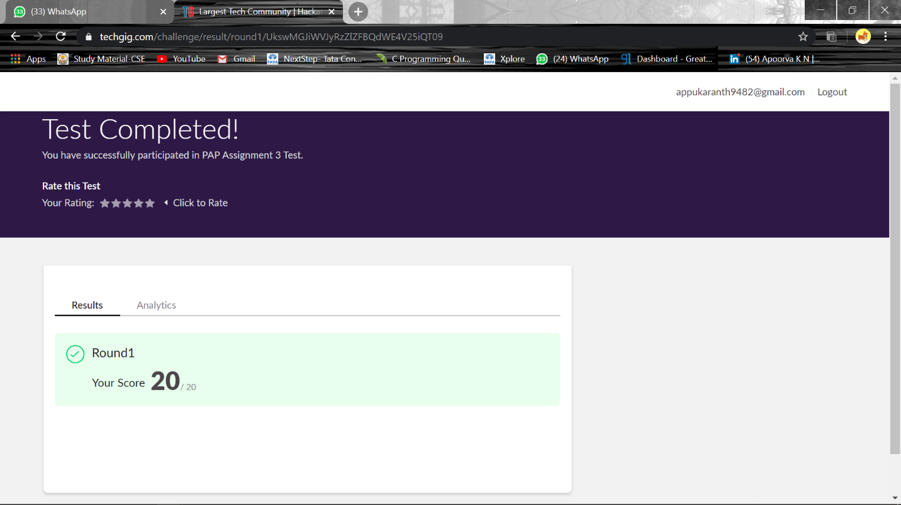

**Online Certification Details**

Modules completed:

- Ethical Hacking in Network Architecture-Demonstration

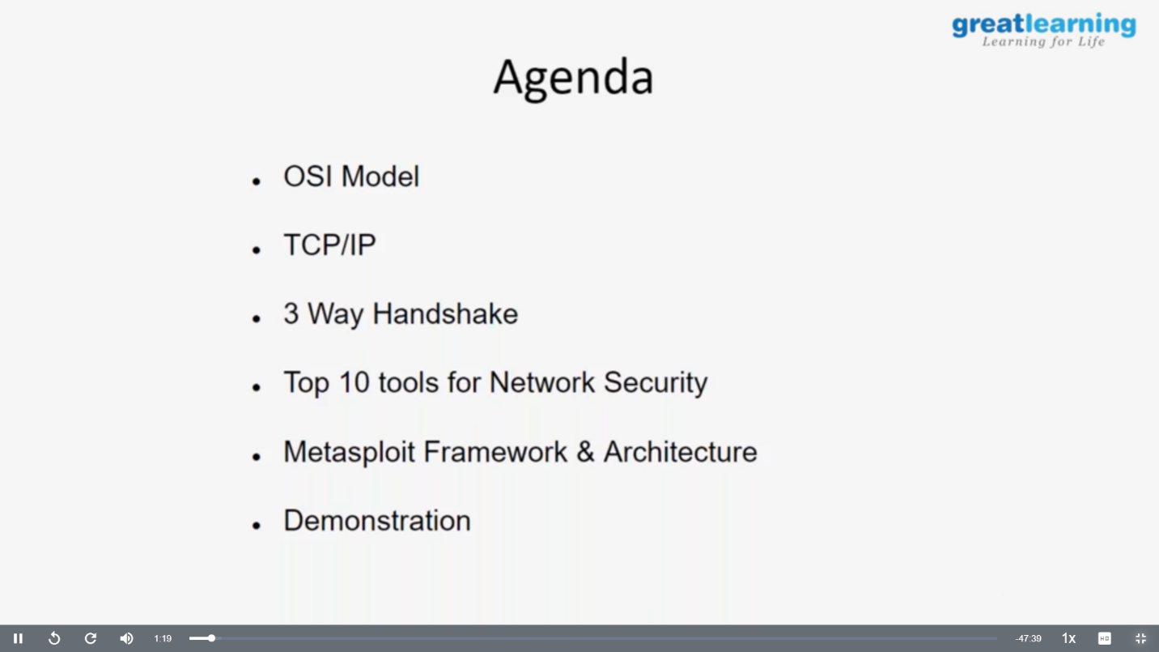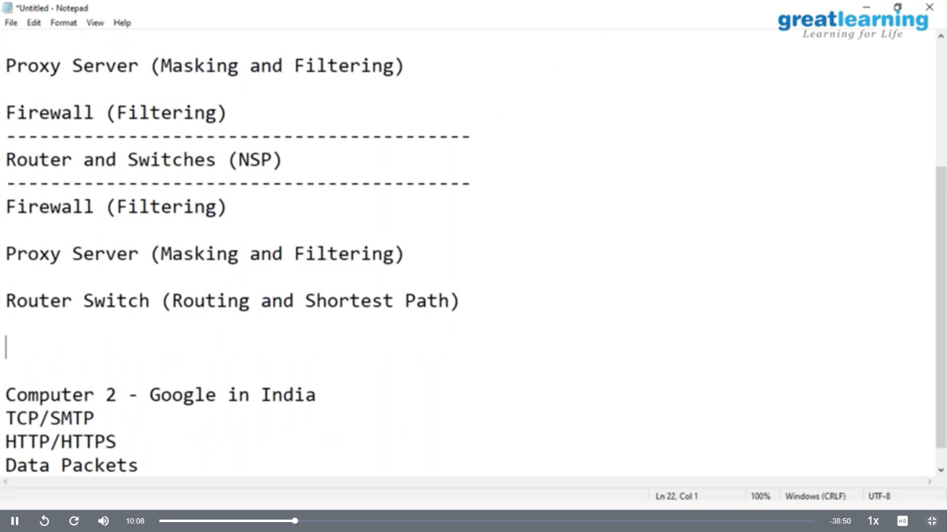

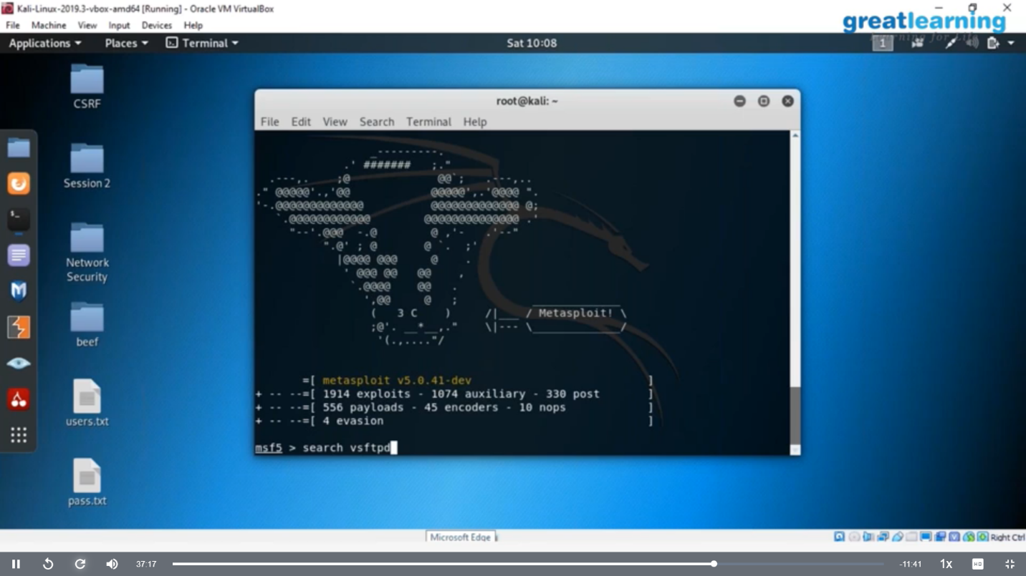

**Coding Challenge Details**

1. Write a python function that converts a string to all uppercase, provided it contains at least 2 uppercase characters in the first 4 characters. Else print the string as it is.

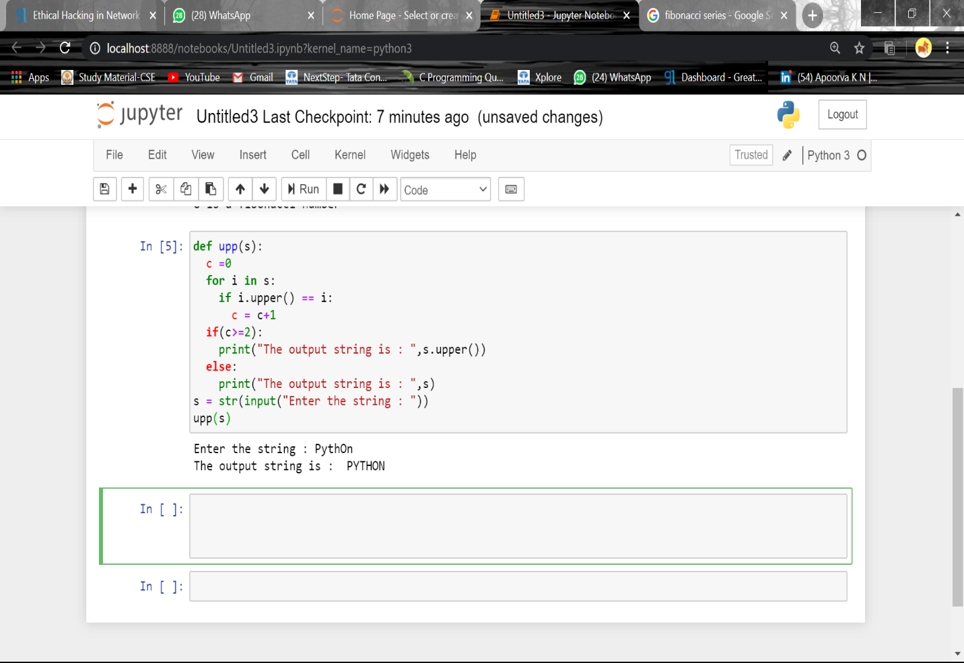

2. Python program to check whether the given number is Fibonacci or not

